Colours:

Well this is useful:

https://material.google.com/style/color.html#color-color-palette

Please see the Colour Palette frile for a complete list of useful colours that can be used in android

Adding Android Colours

Refer to standard Android Colours like this:
android:background="@android:color/white"
This is a list of the standard colours:
int | BLACK
int | BLUE
int | CYAN
int | DKGRAY
int | GRAY
int | GREEN
int | LTGRAY
int | MAGENTA
int | RED
int | TRANSPARENT
int | WHITE
int | YELLOW

Refer to the colours you have defined like this:
android:background="@color/white
Colours can be added by simply setting backgound to a hex value above (in quotations) but its generally best to set them up in the colors.xml resource file to give them a name etc. This means they can all be edited in one place.

The android Material Theme:
https://developer.android.com/training/material/theme.html
There are three special colour values in Android that are used for the default styling (the Material Theme) andorid is naturally designed to do. Whilst you don't have to use these for everything, they interact with the rest of the default layout well, so its generally best not to work against it:
<color name="colorPrimary">#CC0505</color>
<color name="colorPrimaryDark">#9E1010</color>
<color name="colorAccent">#CC0505</color>

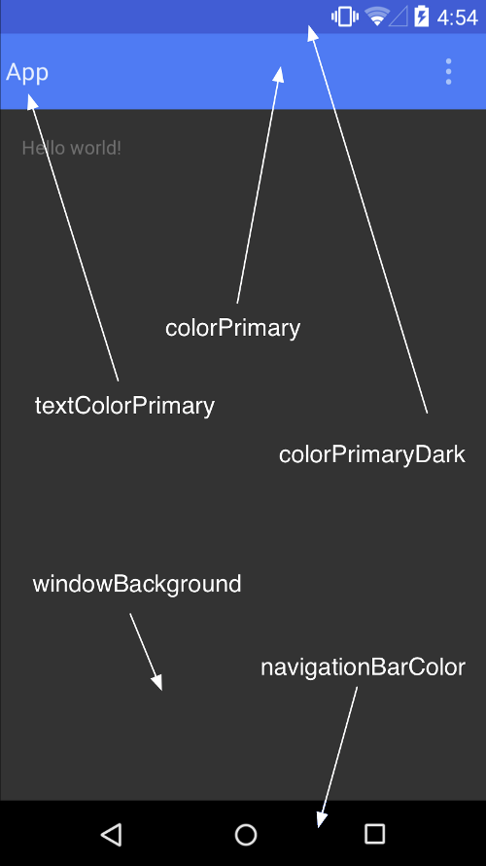
This thing is the status bar:
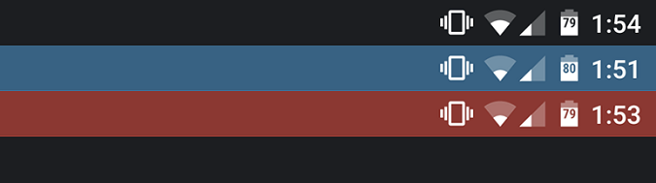

it will inheret from colorPrimary Dark by default. To set a custom color for the status bar, use the android:statusBarColor attribute when you extend the material theme.

You can also draw behind the status bar yourself. For example, if you want to show the status bar transparently over a photo, with a subtle dark gradient to ensure the white status icons are visible. To do so, set the android:statusBarColor attribute to @android:color/transparent and adjust the window flags as required. You can also use the Window.setStatusBarColor() method for animations or fading.
Note: The status bar should almost always have a clear delineation from the primary toolbar, except for cases where you show edge-to-edge rich imagery or media content behind these bars and when you use a gradient to ensure that the icons are still visible.
When you customize the navigation and status bars, either make them both transparent or modify only the status bar. The navigation bar should remain black in all other cases.

